Simulating and Optimizing Robot Path Planning Algorithms

  - User & Developer Manual
Version: 1.0

Author: Vignesh Veeregowda
Table of Contents
Overview 4
Intended Audience 4
System Requirements 4
Quick Feature Summary 4
Architecture & File Overview 5
System Layers & Responsibilities 5
File Roles 6
Data Contracts 8
App Interface Tour 11
Map Tab 11
Config Tab 12
Algorithm Panels 12
Customize Robot 15
Export Settings 16
Dynamic Obstacles 17
Workspace Tab 18
Functional Overview 19
Functional Capabilities Summary 20
General Workflow 20
Algorithm Reference 20
A* Search 20
Dijkstra 20
RRT (Rapidly-Exploring Random Tree) 21
Potential Field (PF) 21
Metrics and Exports 22
Performance Metrics 22
Export Outputs 22

List of Figures
Figure 1: System Layers 5
Figure 2: dynamicObstaclesUI struct 9
Figure 3: Map tab: select a preset or upload your own; preview before sending to Workspace. 11
Figure 4: Config tab sections: Algorithm, Robot, Recording, and Dynamic Obstacles. 12
Figure 5: Algorithm selection drives which parameter panel is shown. 13
Figure 6: Algorithm panels and parameter fields. 14
Figure 7: Robot rendering settings used for path & overlay visuals. 16
Figure 8: Enable video recording; adapters write frames during animation. 16
Figure 9: Define moving obstacles with start to end motion and a speed. 17

List of Tables
Table 1: System Requirements 4
Table 2: Feature Summary 4
Table 3: App file, Algorithm Adapters and Utility Files 6
Table 4: Map Tab Interface 11
Table 5: Algorithm Selection Interface 13
Table 6: A* Panel Interface 14
Table 7: Dijkstra Panel Interface 14
Table 8: RRT Panel Interface 15
Table 9: PF Panel Interface 15
Table 10: Robot Customisation Interface 16
Table 11: Export Settings Interface 17
Table 12: Dynamic Obstacles Interface 17
Table 13: Workspace Tab Interface 18
Table 14: Operational Sequence Summary 19
Table 15: A* configuration as implemented 20
Table 16: Dijkstra configuration as implemented 21
Table 17: RRT configuration as implemented 21
Table 18: PF configuration as implemented 21
Table 19: Performance metrics reported in the Metrics Panel 22
Table 20: Exported artefacts generated by Export button 22
Table 21: results/metrics.csv columns 23

Overview
PathPlanningWorkbench is an interactive MATLAB App Designer tool designed to visualize and compare classical path-planning algorithms - A*, Dijkstra, RRT, and Potential Field — within a unified simulation environment.
It allows users to:
- Load and preprocess maps (preset or custom).
- Select start and goal points directly on the workspace.
- Configure algorithm-specific parameters.
- Simulate path planning with optional dynamic obstacles.
- Evaluate results through performance metrics and exports.
The app serves both didactic (learning and demonstration) and development (testing and benchmarking) purposes, combining interactivity, visualization, and quantitative analysis.

Intended Audience
- Students learning motion-planning algorithms.
- Researchers/Developers testing algorithm performance in MATLAB.
- Future maintainers extending or integrating the tool into other robotics projects.

System Requirements
Table 1: System Requirements
COMPONENT | MINIMUM REQUIREMENT
MATLAB Version | R2023a or later
Toolboxes | Image Processing Toolbox, Robotics System Toolbox
Hardware | ≥ 8 GB RAM, ≥ 2 GB VRAM recommended for video recording
Supported OS | Windows 10/11, macOS 13+, Ubuntu 20.04+

Quick Feature Summary
Table 2: Feature Summary
FEATURE | DESCRIPTION
Multi-Algorithm Comparison | Run and visualize A*, Dijkstra, RRT, and PF in one interface.
Dynamic Obstacles | Add movable dynamic obstacles with start/end paths.
Recording | Generate real-time simulation videos (MP4/GIF).
Metrics | Compute total time, algorithm time, path length, and smoothness.
 | Automatically save map snapshot, CSV path, JSON metrics, and video.
  Export

Architecture & File Overview
This section describes how the PathPlanningWorkbench app is organized internally — from user interaction through algorithm execution to result export.
It helps future developers understand where each functionality resides and how data flows between components.

System Layers & Responsibilities

Figure 1: System Layers

- Interface Layer (App UI, PathPlanningWorkbench.mlapp)
- Presents Map, Config, Workspace tabs.
- Holds all controls (algorithm panels; robot shape/size/color; recording; dynamic-obstacle table).
- Owns axes and metrics panel.
- Never implements algorithm logic.

- Control Layer (Callbacks inside .mlapp)
- Validates prerequisites (map/start/goal).
- Normalizes UI values into baseParams and per-algorithm params.
- Converts dynamic-obstacle rows $→$ structs.
- Dispatches to the chosen adapter (runAStar_app, runDijkstra_app, runRRT_app, runPT_app).
- Updates metrics panel and composes app.LastRun.
- Orchestrates Export (PNG/CSV/JSON/video copy).

- Algorithm Layer (Adapters: runAStar_app.m, runDijkstra_app.m, runRRT_app.m, runPT_app.m)
- Execute a planner given (mapFile, start, goal, params, axes).
- Compute and return R result (path, metrics, timings; optional handles/video hints).
- May animate on axes (optional) and populate R.video.path if recording.

- Utility Layer (Shared helpers)
- Map Processing & Pre-Run Setup (preprocessMap.m, inflateObstacles.m)
- Dynamic Obstacles & Motion Management (updateDynamicObstacles.m etc)
- Path Visualisation & Post-Processing (selectStartGoal.m, plotPath_onAxes.m etc)
- Recording & Export Utilities (startRecorder.m etc)

- Data Layer (Contracts)
- app.State — session state and UI mirrors.
- params — normalized input to adapters (common + algorithm-specific).
- R — adapter output schema consumed by the app.

File Roles
The main .mlapp file along with the adapters are shown in the below table:
Table 3: App file, Algorithm Adapters and Utility Files
FILE | LAYER | RESPONSIBILITY | EDIT THIS WHEN YOU…
GUI Application
PathPlanningWorkbench.mlapp | Interface + Control | UI, callbacks, params packing, dispatch, metrics display, export | Add/rename controls; wire new algorithm; change exports; adjust what goes into params
Algorithm Adapter files
runAStar_app.m | Algorithm | A* (grid-based heuristic) | Tune costs/heuristic/animation; timing granularity
runDijkstra_app.m | Algorithm | Dijkstra (uniform-cost) | Tune costs/queue policy/animation
runRRT_app.m | Algorithm | RRT (sampling tree + smoothing) | Change step/goal bias/smoothing/collision policy
runPT_app.m | Algorithm | Potential Field | Tune potential rules;
Map Processing & Pre-Run Setup
preprocessMap.m | Utility | Converts a colour map image into a binary occupancy grid, applies thresholding, resizes, or adjusts contrast for path-planning use. | Change how images are binarised or when introducing new map formats (e.g. grayscale TIFFs).
inflateObstacles.m | Utility | Expands obstacles in a binary map by a robot-radius using morphological dilation (strel('square', r)). | Adjust inflation logic to match robot footprint or to adopt circular kernels.
Dynamic Obstacles & Motion Management
updateDynamicObstacles.m | Utility | Central dispatcher that moves dynamic obstacles each frame, checks boundaries, and returns updated grid + object array. | Add new motion modes (e.g. looping, random walk) or extend to 3-D.
moveDynamicObstacle.m | Utility | Advances one obstacle along its start$→$ end vector based on speed; flips direction at target. | Modify motion profile or boundary handling.
normalizeDynObstacles.m | Utility | Sanitises obstacle array (fills missing fields, ensures numeric sizes, valid start/end). | Add new obstacle fields or perform integrity checks before simulation.
ensureDynFields.m | Utility | Creates missing struct fields (start, end, size, speed, pos, hPatch) to maintain schema consistency. | When adding new visual/physical fields to the obstacle structure.
createOrUpdateDynPatch.m | Utility | Draws or updates a MATLAB patch/circle representing an obstacle on axes; colour-codes and stores handle. | Change obstacle visual style, transparency, or colour map.
Path Visualisation & Post-Processing
plotPath_onAxes.m | Utility | Draws the computed path (pathXY) on workspace axes with start/goal markers and chosen robot colour. | Change line style, colour scheme, or marker rendering.
smoothPath.m | Utility | Applies post-processing smoothing to RRT or grid paths using corner-reduction or polynomial fit. Returns new coordinates and smoothness metric. | Introduce alternative smoothing algorithms or adjust tolerance.
selectStartGoal.m | Utility | Handles mouse-click input for selecting start and goal on the map; includes clamping within image bounds. | Modify picking logic (e.g. multi-goal support or drag-drop).
Recording & Export Utilities
startRecorder.m | Utility | Initializes a VideoWriter object (or GIF frame array) with chosen format / fps / filename. | Support new formats or change compression profiles.
recordFrame.m | Utility | Captures the current axes frame and writes it to the active recorder; used during live animation. | Adjust capture resolution or cropping behaviour.
stopRecorder.m | Utility | Closes and finalizes the video stream, ensuring the file is saved correctly. | Add post-processing (e.g. frame rate correction or overlay).

Data Contracts
A) app.State (owned by the app; partial list of fields actually present)
- mapRaw (image shown), mapFile (string)
- start, goal — [x y] pixel coords (image space)
- algo — "AStar"|"Dijkstra"|"RRT"|"PF"
- dynEnabled — logical (mirrors Config $→$ Dynamic Obstacles toggle)
- Processing override: procOverride (logical), procFile (string)
- Recording mirror: recordEnabled (logical)
B) params (input to adapters — what the app actually builds)
Common block (baseParams) constructed in RunButtonPushed:
- robotShape — lower(string(app.RobotShapeDropdown.Value)) → "square" or "disk"
- robotSize — app.RobotSizeEditField.Value
- robotColor — app.RobotColorColorPicker.Value (1×3 RGB double)
- dynEnabled — app.State.dynEnabled
- dynamicObstaclesUI — struct[] (see below)
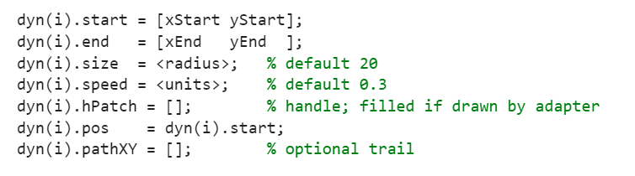
Figure 2: dynamicObstaclesUI struct
- useProcessingOverride — app.State.procOverride
- processingMapFile — app.State.procFile
- record — struct with:
  - enable — logical(app.RecordEnableCheck.Value) (fallback default false)
  - format — char(app.RecordFormatDropDown.Value), defaulted to 'MP4'
  - fps — app.RecordFPSNumericEditField.Value, defaulted to 30
Per-algorithm additions (actual assignments in .mlapp):
- A*
  - costStraight = app.AStarStraightFieldEditField.Value
  - costDiagonal = app.AStarDiagFieldEditField.Value
- Dijkstra
  - costStraight = app.DijkstraStraightFieldEditField.Value
  - costDiagonal = app.DijkstraDiagFieldEditField.Value
- RRT
  - rrtMaxIterations = max(1, round(app.MaxItersEditField.Value))
  - rrtStepSize = max(1, round(app.StepSizeSlider.Value))
  - rrtGoalBias = max(0, min(1, app.GoalBiasSlider.Value))
  - rrtGoalRadius = max(1, round(app.GoalRadiusSlider.Value))
  - rrtMaxSmoothDist = max(1, round(app.SmoothMaxDistSlider.Value))
- Potential Field
  - pf_k_att = app.AttractiveGainzetaEditField.Value
  - pf_k_rep = app.RepulsiveGainetaEditField.Value
  - pf_Qstar = app.QstarInfluenceradiuspxEditField.Value
  - pf_maxIts = app.MaxIterationsEditField.Value
  - pf_tol = app.ToleranceEditField.Value
  - pf_MaxSmoothDist = app.SmoothMaxDistSlider_PF.Value
C) R (adapter return struct — what the app reads)
- success — logical
- pathXY — N×2 double [x y] in pixel coords
- pathLen — double (sum of Euclidean segment lengths)
- smoothness — double (sum of wrapped $|Δθ|$; app displays it, adapter computes it)
- algorithmTime — double seconds (core planning time)
- totalTime — double seconds (end-to-end including I/O/animation if measured)
- video.enabled — logical (optional)
- video.path — string (optional; temp file path; Export will copy it)
- meta.handles — struct (optional; e.g., obstacle graphics for cleanup)
The app’s metrics panel reads directly from R (it does not recompute).
D) Algorithms exposed in the UI
The algorithm dropdown drives a switch in RunButtonPushed with the following labels:
- "AStar", "Dijkstra", "RRT", "PF" (exact tokens matched in code).
Each case clones baseParams into params, then adds its own fields (Section 2.3).

App Interface Tour
This section walks through the UI tab by tab. For each feature you’ll see:
- Control name (as seen in the UI).
- What it does.
- Affects (state/visuals).
- Mapped to params.

Map Tab
  - Purpose: choose and preview a map, then push it into the Workspace.
The Map tab provides functions for importing, previewing, and selecting maps used in path-planning simulations. It supports both preset and custom image files. A processing override option enables the use of a separate map file for algorithmic computation while maintaining a distinct display map in the workspace.
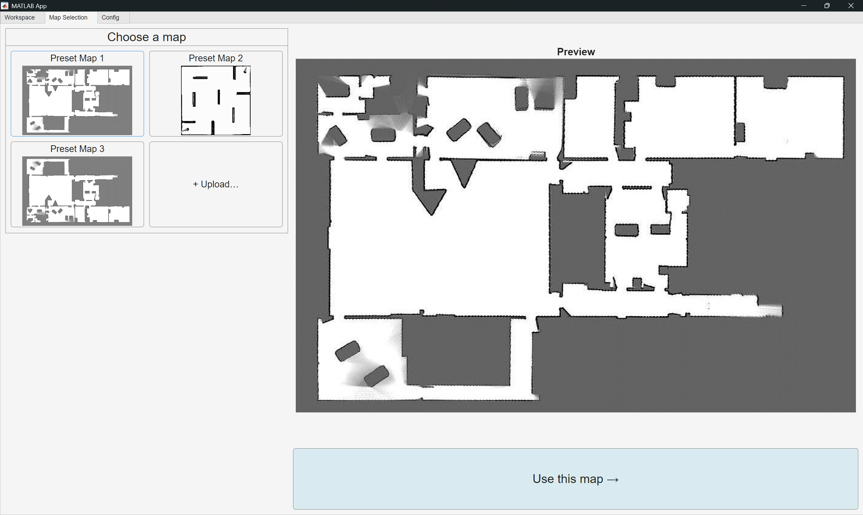
Figure 3: Map tab: select a preset or upload your own; preview before sending to Workspace.
Table 4: Map Tab Interface
CONTROL / UI AREA | WHAT IT DOES | AFFECTS | MAPPED TO PARAMS
Preset Map buttons (e.g., Preset 1/2/3) | Loads a bundled map into Map Preview | app.State.mapRaw (preview only) | —
Upload… | Browse and preview a custom image map | app.State.mapRaw (preview) | —
Map Preview Axes | Shows the currently selected image | Visual only | —
Use This Map | Pushes previewed map to Workspace | app.State.mapFile (display/processing source), image drawn on WorkspaceAxes | Later: baseParams.useProcessingOverride, baseParams.processingMapFile may switch processing source

Config Tab
  - Purpose: set algorithm parameters, robot style, recording, and dynamic obstacles.
The Config tab contains all configuration settings related to algorithm selection, parameter definition, robot representation, recording options, and dynamic obstacle setup. The controls on this tab collectively define the planning parameters that are compiled into the params structure prior to algorithm execution.
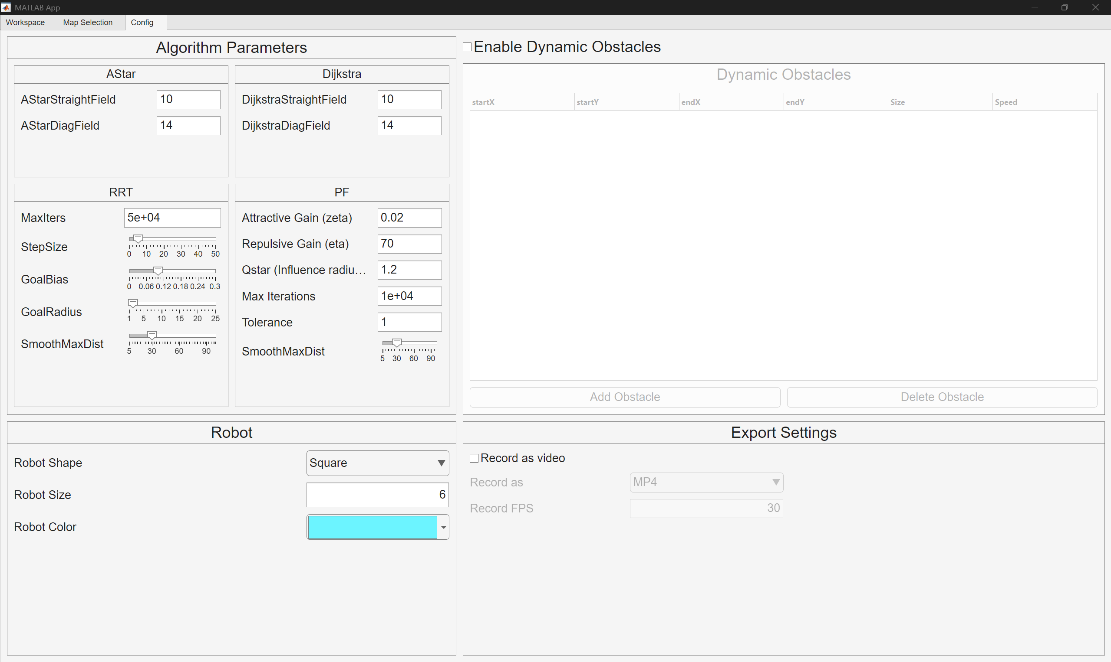
Figure 4: Config tab sections: Algorithm, Robot, Recording, and Dynamic Obstacles.

Algorithm Panels
The Algorithm Panels subsection defines the configuration parameters specific to each path-planning algorithm supported by the application. Each algorithm panel exposes tunable fields that control search cost, sampling behaviour, or potential-field dynamics. The selected panel is activated based on the algorithm chosen from the main dropdown menu, and all parameter values are compiled into the params structure during execution. This design enables consistent parameter handling across multiple algorithms while maintaining clear visual separation in the interface.
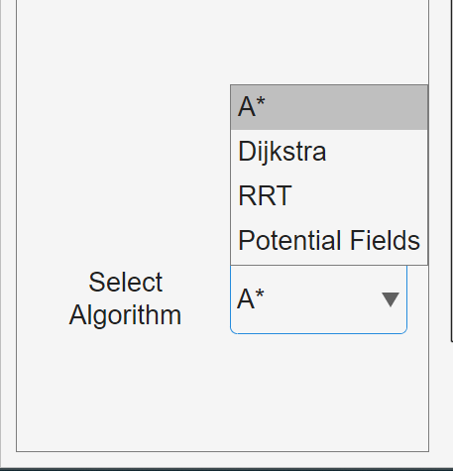
Figure 5: Algorithm selection drives which parameter panel is shown.
Note: All parameters are shown in figure 4 only for ease of understanding, the actual working of the app is different.
Table 5: Algorithm Selection Interface
CONTROL | WHAT IT DOES | AFFECTS | MAPPED TO PARAMS
Algorithm Dropdown | Chooses planner: AStar, Dijkstra, RRT, PF | app.State.algo | Switch in RunButtonPushed selects adapter

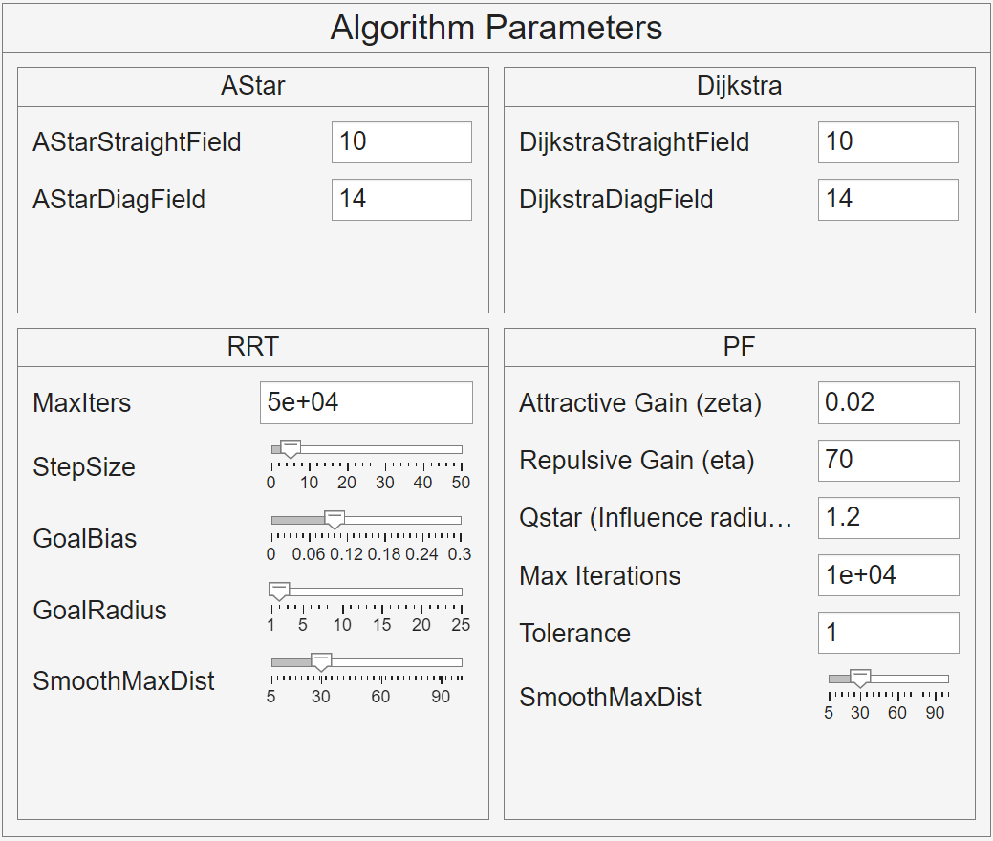
Figure 6: Algorithm panels and parameter fields.

A*
Table 6: A* Panel Interface
CONTROL | WHAT IT DOES | AFFECTS | MAPPED TO PARAMS
Straight cost (AStarStraightFieldEditField) | Cost of orthogonal moves | Planning weights | costStraight
Diagonal cost (AStarDiagFieldEditField) | Cost of diagonal moves | Planning weights | costDiagonal

Dijkstra
Table 7: Dijkstra Panel Interface
CONTROL | WHAT IT DOES | AFFECTS | MAPPED TO PARAMS
Straight cost (DijkstraStraightFieldEditField) | Cost of orthogonal moves | Planning weights | costStraight
Diagonal cost (DijkstraDiagFieldEditField) | Cost of diagonal moves | Planning weights | costDiagonal

RRT
Table 8: RRT Panel Interface
CONTROL | WHAT IT DOES | AFFECTS | MAPPED TO PARAMS
Max iterations (MaxItersEditField) | Hard cap on node expansions | Runtime / completeness | rrtMaxIterations = max(1, round(Value))
Step size (StepSizeSlider) | Edge length per expansion | Tree growth / collision | rrtStepSize = max(1, round(Value))
Goal bias (GoalBiasSlider) | Probability of sampling goal | Convergence tendency | rrtGoalBias = clamp01(Value)
Goal radius (GoalRadiusSlider) | Acceptable goal capture distance | Termination | rrtGoalRadius = max(1, round(Value))
Smooth max dist (SmoothMaxDistSlider) | Max segment length for smoothing | Post-processing | rrtMaxSmoothDist = max(1, round(Value))

Potential Field
Table 9: PF Panel Interface
CONTROL | WHAT IT DOES | AFFECTS | MAPPED TO PARAMS
Attractive gain (AttractiveGainzetaEditField) | Strength of pull towards goal | Potential strength | pf_k_att
Repulsive gain (RepulsiveGainetaEditField) | Strength of push from obstacles | Repulsion magnitude | pf_k_rep
Q* Influence radius (px)  (QstarInfluenceradiuspxEditField) | Distance over which repulsion acts | Field shape | pf_Qstar
Max iterations (MaxIterationsEditField) | Upper bound on PF solver steps | Runtime / convergence | pf_maxIts
Tolerance (ToleranceEditField) | Stopping criterion on gradient/step | Convergence | pf_tol
Smooth max dist (SmoothMaxDistSlider_PF) | Max segment length used by smoothing pass | Post-processing smoothness | pf_MaxSmoothDist

Customize Robot
The Robot Appearance controls specify the geometric and visual attributes of the robot within the simulation environment. These parameters determine how the robot is represented during path visualisation and influence certain preprocessing steps such as obstacle inflation. The selected shape, size, and colour are transferred into the parameter structure and used both for display and metric computation.
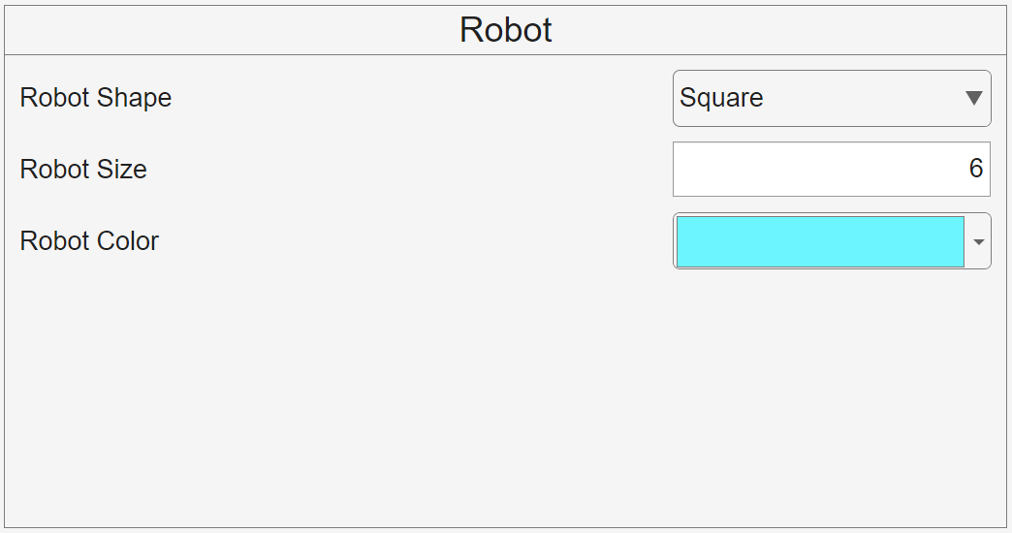
Figure 7: Robot rendering settings used for path & overlay visuals.
Table 10: Robot Customisation Interface
CONTROL | WHAT IT DOES | AFFECTS | MAPPED TO PARAMS
Shape (RobotShapeDropdown) | "square" or "disk" | Draw style (and may inform inflation) | robotShape
Size (RobotSizeEditField) | Radius/half-width in px | Inflation / visuals | robotSize
Color (RobotColorColorPicker) | RGB | Path/robot colour | robotColor

Export Settings
The Export Settings subsection provides options for capturing a video representation of the simulation. When recording is enabled, the application creates a video writer object and stores successive frames during algorithm execution. The output format and frame rate are user-definable, allowing control over video size and playback smoothness. Recording parameters are stored within params.record and passed to the adapter to manage frame capture and finalisation.
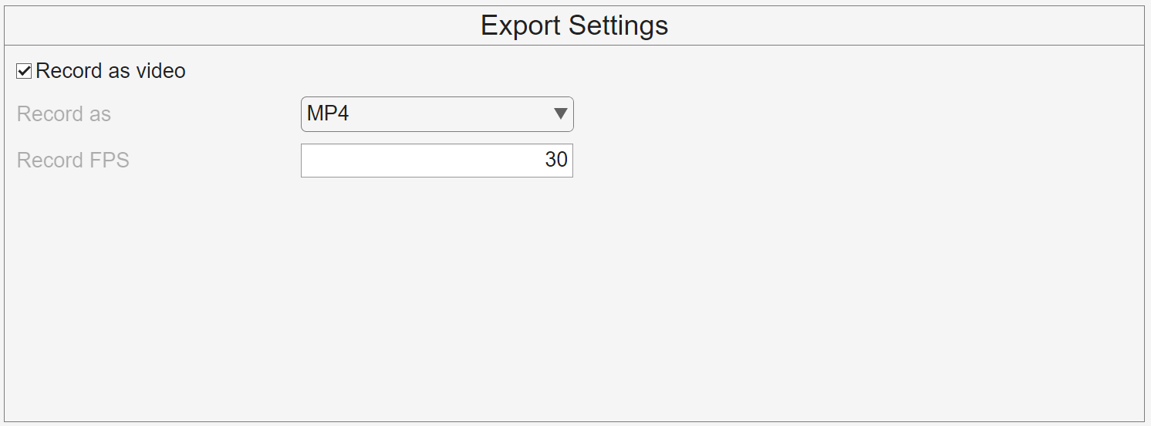
Figure 8: Enable video recording; adapters write frames during animation.
Table 11: Export Settings Interface
CONTROL | WHAT IT DOES | AFFECTS | MAPPED TO PARAMS
Record as video (RecordEnableCheck) | Enable/disable capture | app.State.recordEnabled, enables other controls | record.enable
Format (RecordFormatDropDown) | e.g., MP4 | Encoding container | record.format (default 'MP4')
FPS (RecordFPSNumericEditField) | Frames per second | Smoothness vs size | record.fps (default 30)

Dynamic Obstacles
The Dynamic Obstacles configuration allows the definition of moving entities within the map environment. Each obstacle is characterised by start and end coordinates, size, and speed, which together define its motion path. Obstacles are stored as structured entries and updated during runtime by the dynamic-obstacle management utilities. These parameters influence both path generation and animation, enabling simulation of time-varying environments.
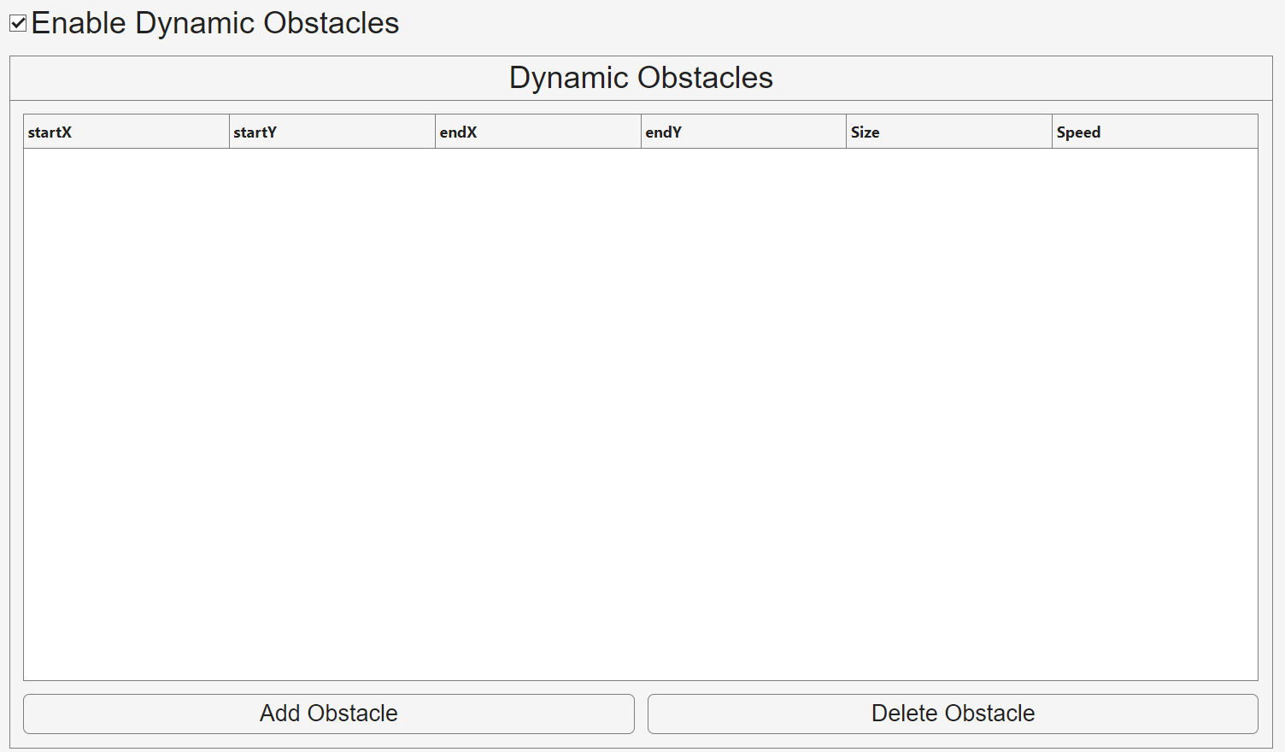
Figure 9: Define moving obstacles with start to end motion and a speed.
Table 12: Dynamic Obstacles Interface
CONTROL | WHAT IT DOES | AFFECTS | MAPPED TO PARAMS
Enable dynamics (DynEnabledCheck) | Turns dynamic obstacles on/off | app.State.dynEnabled | baseParams.dynEnabled
Add obstacle | Starts guided pick: click START then END in Workspace | App’s obstacle table row | Converted into dynamicObstaclesUI(i) with fields below
Delete obstacle | Removes selected/last row | Table state | —
Obstacles Table (ObstaclesTable) | Columns: startX startY endX endY size speed | Stored rows | Converted per row into: start, end, size, speed, with pos=start, hPatch=[], pathXY=[]
(internal set) | Visual handle for obstacle patch | Draw state | dynamicObstaclesUI(i).hPatch (adapter may set)

Workspace Tab
Purpose: interactive map view, picking start/goal, running algorithms, viewing metrics, and exporting results.
The Workspace tab serves as the main simulation and visualisation area. It facilitates the specification of start and goal coordinates, displays generated paths and dynamic elements, presents performance metrics, and provides options for exporting results and visual records of the run.

Table 13: Workspace Tab Interface
CONTROL | WHAT IT DOES | AFFECTS | MAPPED TO PARAMS
Workspace Axes (WorkspaceAxes) | Main canvas for map, path, and dynamic objects | Visuals (app.Graphics.hPath, obstacle patches) | —
Pick Start (toggle) | Enter start-pick mode → click on axes | app.State.start = [x y] | Used as startXY argument
Pick Goal (toggle) | Enter goal-pick mode → click on axes | app.State.goal = [x y] | Used as goalXY argument
Run (RunButton) | Validates, assembles baseParams + per-algo params, calls adapter | Populates app.LastRun and metrics | Params mention in Config Tab section; adapter returns R
Reset (ResetButton) | Clears overlays and pick state | app.Graphics handles; labels reset | —
Metrics Panel | Displays R.success, R.totalTime, R.algorithmTime, R.pathLen, R.smoothness | UI labels | Read from R (adapter-supplied)
Export… (ExportButton) | Saves snapshot PNG, path CSV, metrics JSON, params JSON, copies video | Files in chosen folder | Uses app.LastRun; params = app.LastRun minus path/metrics/video

Functional Overview
This section provides a consolidated overview of the principal operations supported by PathPlanningWorkbench.
It summarises the functional capabilities of the application and outlines the general sequence of actions performed during a complete planning session.
The description is intended to convey the overall workflow and interactive features rather than detailed implementation logic.
Table 14: Operational Sequence Summary
STAGE | PRIMARY ACTIONS | RESULT / SYSTEM RESPONSE | RELATED TABS OR COMPONENTS
1. Map Selection and Preparation | A map is selected from available presets or imported from an external image file.  The chosen map is previewed and confirmed for use in the workspace. Optional processing-override files can be assigned for algorithmic computation. | The selected map becomes the active planning surface and is displayed in the workspace area. | Map Tab
2. Start and Goal Definition | Start and goal coordinates are specified by enabling the respective selection modes and clicking on the workspace map.  The selections are displayed as markers. | The application records the positions and stores them in session state for use by the planning algorithm. | Workspace Tab
3. Algorithm Configuration | An algorithm is chosen from the dropdown menu, and its parameters are adjusted using the associated configuration panel. | Parameter values are collected and internally prepared for execution. | Config Tab $→$ Algorithm Panels
4. Robot and Environment Setup | The robot’s visual attributes (shape, size, colour) and any dynamic obstacles are configured. | The workspace display and parameter structure are updated to reflect the chosen robot and obstacle definitions. | Config Tab $→$ Robot Appearance / Dynamic Obstacles
5. Recording and Execution | Recording options may be enabled. The Run command initiates planning based on the selected algorithm and configuration. | The workspace displays the resulting path, dynamic obstacle motion (if enabled), and relevant runtime metrics. | Config Tab / Workspace Tab
6. Results and Export | Path, metrics, and optional video outputs can be exported for documentation or further analysis. | The system generates image, CSV, JSON, and video files corresponding to the completed run. | Workspace Tab $→$ Export

Functional Capabilities Summary
- Supports four path-planning algorithms (A*, Dijkstra, RRT, and Potential Field) with independent configuration panels.
- Allows interactive start and goal placement directly on the workspace map.
- Provides dynamic obstacle simulation, including motion visualisation.
- Generates quantitative performance metrics: path length, smoothness, algorithm time, and total time.
- Enables visual recording and export of all run artefacts for analysis or presentation.

General Workflow
A typical session proceeds in the following order:
- Load or import a map on the Map tab.
- Select Algorithm on the Workspace tab.
- Switch to the Config tab to adjust parameters.
- Define robot appearance, dynamic obstacles, and (optionally) enable recording.
- Move to the Workspace tab to specify start and goal positions.
- Execute the algorithm using the Run command.
- Review metrics and export results.

Algorithm Reference
This section documents the planning algorithms available in PathPlanningWorkbench, including a concise overview and the precise configuration parameters as implemented. Values reflect current UI control definitions (Limits, Value, Step) and the mappings performed in RunButtonPushed.

A* Search
Graph-based path search over a grid with user-specified orthogonal and diagonal move costs. Deterministic and optimal with a consistent heuristic (heuristic selection is internal to the adapter).
Table 15: A* configuration as implemented
PARAMETER (PARAMS FIELD) | DESCRIPTION | RANGE (UI) | DEFAULT (UI)
costStraight | Cost of orthogonal moves. | - | 10
costDiagonal | Cost of diagonal moves. | - | 14

Dijkstra
Uniform-cost search over the grid without heuristic. Serves as a baseline for cost-only expansion.
Table 16: Dijkstra configuration as implemented
PARAMETER (PARAMS FIELD) | DESCRIPTION | RANGE (UI) | DEFAULT (UI)
costStraight | Cost of orthogonal moves. | - | 10
costDiagonal | Cost of diagonal moves. | - | 14

RRT (Rapidly-Exploring Random Tree)
Sampling-based exploration with optional goal bias and post-planning smoothing. Parameters are set via numeric field and sliders with explicit limits and steps.
Table 17: RRT configuration as implemented
PARAMETER (PARAMS FIELD) | DESCRIPTION | RANGE (UI) | DEFAULT (UI)
rrtMaxIterations | Maximum expansion steps. | [1, Inf] (numeric field) | 50000
rrtStepSize | Edge length per expansion (pixels). | [0, 50], step 1 | 5
rrtGoalBias | Probability of sampling the goal. | [0, 0.3], step 0.01 | 0.10
rrtGoalRadius | Goal capture radius (pixels). | [1, 25], step 1 (ticks at 1,5,10,15,20,25) | 2
rrtMaxSmoothDist | Max segment length in smoothing (pixels). | [5, 100], step 5 (ticks at 5,30,60,90) | 30

Potential Field (PF)
Sampling-based exploration with optional goal bias and post-planning smoothing. Parameters are set via numeric field and sliders with explicit limits and steps.
Table 18: PF configuration as implemented
PARAMETER (PARAMS FIELD) | DESCRIPTION | RANGE (UI) | DEFAULT (UI)
pf_k_att | Attractive gain (pull toward goal). | [0, 0.1] | 0.02
pf_k_rep | Repulsive gain (push from obstacles). | [1, 1000] | 70
pf_Qstar | Obstacle influence radius (pixels). | [1, 80] | 1.2
pf_maxIts | Maximum solver iterations. | [100, 20000] | 10000
pf_tol | Convergence tolerance (unit per iteration). | [0.5, 5] | 1
pf_MaxSmoothDist | Max segment length in smoothing (pixels). | [5, 100], step 5 (ticks at 5,30,60,90) | 30

Metrics and Exports
This section summarises the quantitative metrics produced by each planning run and the exportable artefacts generated by PathPlanningWorkbench.
The metrics provide both algorithmic and overall performance insights, while the export functions allow archival and external analysis of results.
All values are automatically updated in the Metrics Panel after each run.

Performance Metrics
The application evaluates each completed run through the updateMetricsPanel method.
Five primary indicators are computed from the result structure R returned by every algorithm adapter.
Table 19: Performance metrics reported in the Metrics Panel
METRIC | SYMBOL / VARIABLE | DESCRIPTION | DISPLAY FORMAT
Success | R.success | Logical indicator showing whether a valid path was found between start and goal. | “true” / “false”
Total Time (s) | R.totalTime | Overall elapsed time for the run, including animation and UI rendering. | Decimal, 3 places
Algorithm Time (s) | R.algorithmTime | Pure computational time spent inside the planning algorithm. | Decimal, 4 places
Path Length | R.pathLen | Total Euclidean distance traversed along the generated path. | Decimal, 2 places
Smoothness | R.smoothness | Quantitative smoothness measure derived from angular changes along the path. | Decimal, 2 places

Export Outputs
After a successful run, all relevant results and configurations are stored in the app.LastRun structure and exported through the Export button.
The system creates a timestamped export bundle in a user-selected folder.
Table 20: Exported artefacts generated by Export button
OUTPUT TYPE | FILE EXTENSION | CONTENTS / DESCRIPTION
Snapshot Image | .png | Static image capture of the current WorkspaceAxes, including map, start/goal, path, and obstacles.
Path Coordinates | .csv | Two-column list (x,y) of ordered path points.
Metrics Summary | .json | JSON-encoded metrics identical to those displayed in the panel.
Run Parameters | .json | Full configuration data: algorithm name, map files, robot parameters, obstacle table, region/scenario IDs, and dynamic settings.
Video Recording | .mp4 or .gif | Optional visual replay of the run when recording is enabled (FPS range 1–60, default 30).

File Naming and Storage
Each export set is named using the convention
<Algorithm>_<MapName>_<YYYYMMDD_HHMMSS>_<Artifact>
and saved in the folder chosen by the user.
Machine-Readable Schemas (CSV)
Internally, a cumulative log of all runs is appended to
results/metrics.csv in the application’s working directory for cross-run benchmarking.
Table 21: results/metrics.csv columns
Column | Type | Meaning
Map | string | Display map file used in the workspace.
MapProcessed | string | Processing/algorithm map (may differ if processing override was used).
Algorithm | string | Planner label from the dropdown (AStar, Dijkstra, RRT, PF).
Success | logical | true if a valid path was found.
TotalTime | double (s) | Wall-clock elapsed time including orchestration/animation.
AlgoTime | double (s) | Core planning time (adapter only).
PathLen | double (px) | Euclidean length of returned path polyline.
Smoothness | double (rad) | Sum of absolute heading changes along path.
RobotShape | string | "disk" or "square".
RobotSize | double (px) | Radius/half-width used for inflation and visuals.
RobotColor | string | RGB triple serialized as string (e.g., "[0.1 0.5 0.9]").
DynEnabled | logical | Whether dynamic obstacles were enabled.
DynCount | double (count) | Number of dynamic obstacles configured.
Region | string | Region tag (free text; defaults to "R1").
ScenarioID | string | Scenario label (e.g., "A").
Seed | double | RNG seed (numeric; NaN if not set).
RRT_Step | double (px) | RRT step size. NaN for non-RRT runs.
RRT_Iter | double | RRT max iterations. NaN if not applicable.
RRT_GoalBias | double (0-1) | RRT goal-sampling probability. NaN if N/A.
PF_k_att | double | PF attractive gain. NaN if not PF.
PF_k_rep | double | PF repulsive gain. NaN if not PF.
PF_Qstar | double (px) | PF influence radius. NaN if not PF.
Thresh | double | Map binarisation threshold used (if supplied).
Replans | double (count) | Number of re-plans counted (if tracked).
StartX | double (px) | Start x-coordinate.
StartY | double (px) | Start y-coordinate.
GoalX | double (px) | Goal x-coordinate.
GoalY | double (px) | Goal y-coordinate.

Developer Notes
- Export JSON files are written using MATLAB’s jsonencode for cross-platform readability.
- All metrics use consistent units (seconds / pixels).
- The cumulative CSV log supports import into MATLAB, Excel, or Python for extended analysis.

